Changing CenPOS between test and production in M3

Change the CenPOSTokenAPI Service API URL
- Log into M3 and search for API Gateway from top menu. If you don’t see it, request access.
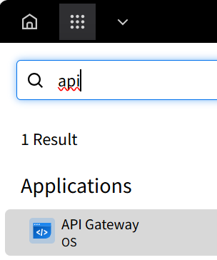
- Search for ‘CenPOS’
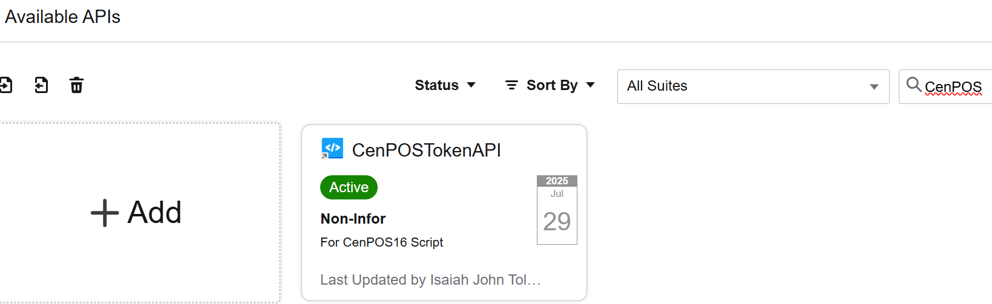
- Click Details arrow
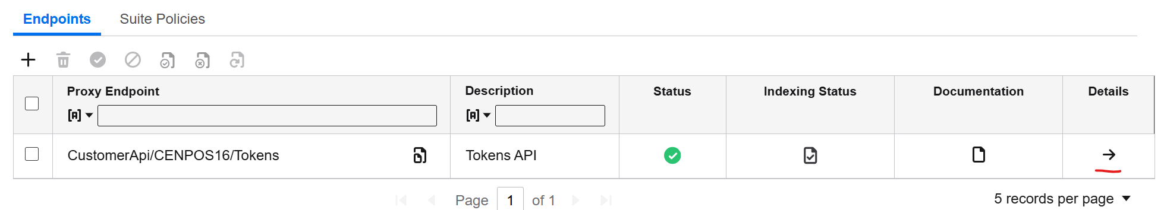
- Change ‘Target Endpoint URL’
Test: https://abistaging.cenpos.net/2/tokens.asmx
Production: https://ww3.cenpos.net/2/tokens.asmx
(Which one is correct, top is what Infor had and matches Test version)
Production: https://ww3.cenpos.net/6/9/tokens.asmx

Change Merchant ID and account information
- Go into M3, CRS434 Credit Card Interface Settings
- Change the following fields
Test
Merchant ID: 790010234
User: Infortest
Password: <Link to keys>
URL address: https://webstaging.cenpos.net/posintegration/posintegration-html5/
Host address: https://abistaging.cenpos.net/6/transact.asmx?wsdl

Production
Merchant ID: 600011066
User: ASR_M3_Service
Password: <Link to keys>
URL address: https://www4.cenpos.net/posintegration/posintegration-html5/
Host address: https://ww4.cenpos.net/6/transact.asmx

Virtual Terminal –
Test: https://webstaging.cenpos.net/vt
Production: https://www.cenpos.net/vt

